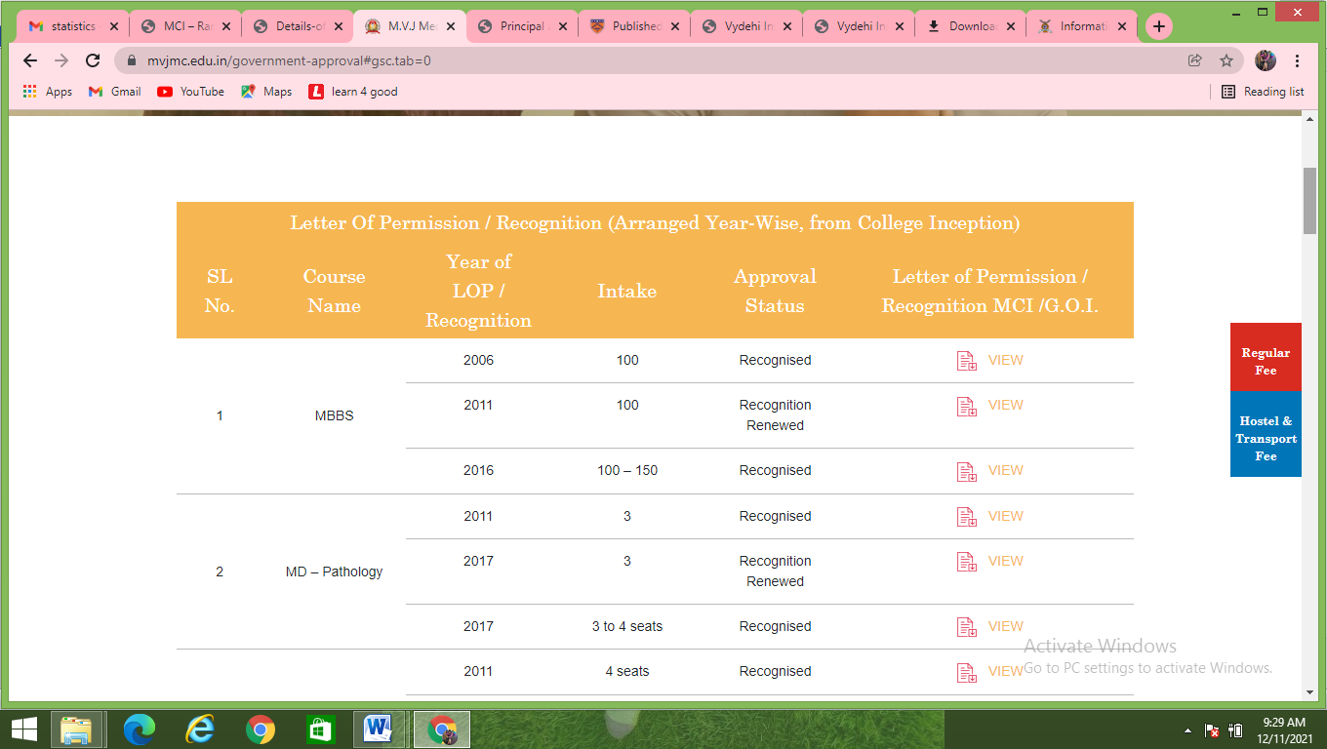

|  |  |  |  |  |
| --- | --- | --- | --- | --- |
|  |  |  |  |  |
| 2020 | MBBS | 150 | RECOGNISED |  |
| 2019 | 150 | RECOGNISED |  |
| 2017 | 150 | RECOGNISED |  |
| 2016 | 150 | RECOGNISED |  |